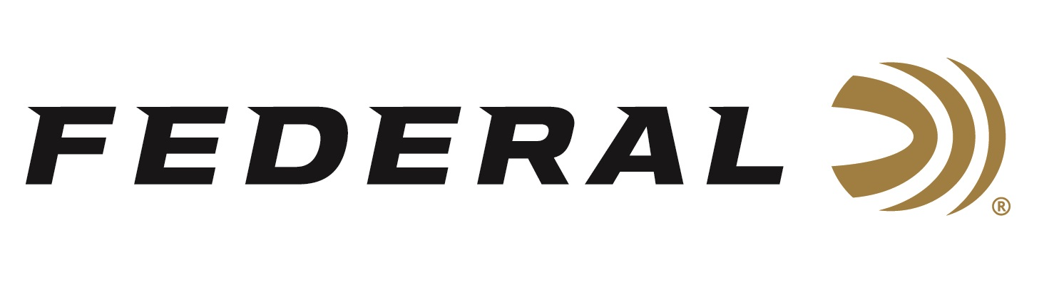

FOR IMMEDIATE RELEASE

Federal Ammunition is the Official Ammunition of the “Crush with Lee & Tiffany”

ANOKA, Minnesota – April 1, 2020 – Federal Ammunition announces a new partnership with the popular television series “Crush with Lee & Tiffany.” Federal will become the official ammunition of The Lakoskys, a popular hunting couple, who have been winning awards and leading ratings since the series launched on Outdoor Channel in 2008.

“This is a great partnership” says Brian Kelvington, Federal Ammunition’s Media Director. “The Lakoskys produce great content and aligning our industry leading products with their award-winning programming is a perfect partnership,” says Kelvington. The Lakoskys will put all of Federal’s product categories to test including our Premium® centerfire line of ammunition, shotshell leaders Black Cloud and Prairie Storm, and the revolutionary new muzzleloader product FireStick.

“This is exciting for our team,” says Tiffany Lakosky. “We have been Federal fans for a long time and being able to represent their entire line-up of products is an honor.” The Lakoskys will start with chasing gobblers this spring with Federal’s Heavyweight® TSS and will be the face of the marketing of FireStick, the whole new ignition system for muzzleloaders. “This is a game changer for muzzleloaders,” says Lee Lakosky. “We can’t wait to employ the new safe, reliable, and consistent propellant charge this fall.”

Fans of the Outdoor Channel show can expect Federal brand and product integration into the edgy and fun programming in early July. Check local listings for dates and airtimes.

Federal ammunition can be found at dealers nationwide or purchased online direct from Federal. For more information on all products from Federal or to shop online, visit www.federalpremium.com.

Press Release Contact: JJ Reich
Senior Manager – Press Relations
E-mail: VistaPressroom@VistaOutdoor.com

About Federal Ammunition
Federal, headquartered in Anoka, MN, is a brand of Vista Outdoor Inc., an outdoor sports and recreation company. From humble beginnings nestled among the lakes and woods of Minnesota, Federal Ammunition has evolved into one of the world's largest producers of sporting ammunition. Beginning in 1922, founding president, Charles L. Horn, paved the way for our success. Today, Federal carries on Horn's vision for quality products and service with the next generation of outdoorsmen and women. We maintain our position as experts in the science of ammunition production. Every day we manufacture products to enhance our customers' shooting experience while partnering with the conservation organizations that protect and support our outdoor heritage. We offer thousands of options in our Federal Premium and Federal® lines-it's what makes us the most complete ammunition company in the business and provides our customers with a choice no matter their pursuit.

